***Concrete Racism: Road-Building, Urban Reconstruction and Race Relations in Baltimore, 1910-2018***

A lecture by

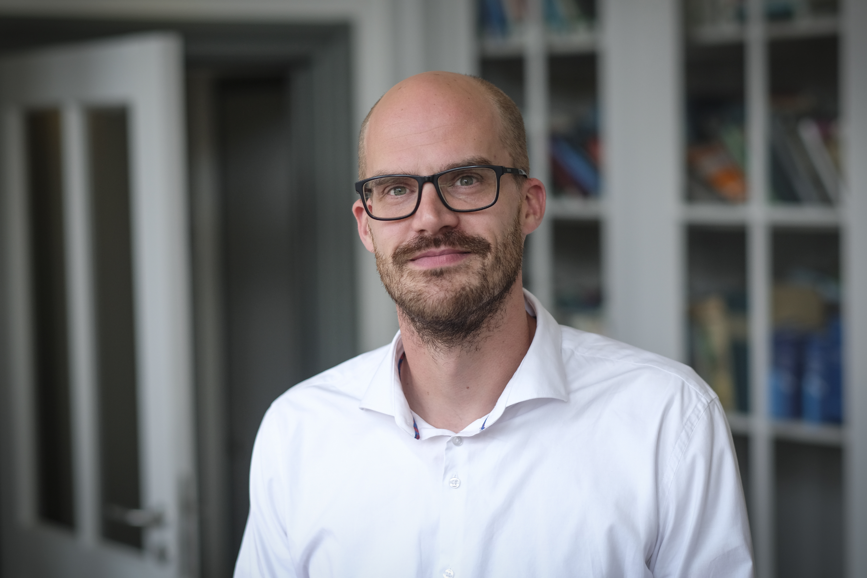

**Vincent Lagendijk**

Assistant Professor of History

Maastricht University, the Netherlands

Wednesday, May 22nd 2019, 19:00-21:00

Lecture Room A, Panepistimioupolis, Ilisia

Department of History and Philosophy of Science

National and Kapodistrian University of Athens

Organizer: Aristotle Tympas

Professor of the History of Technology in Modernity

Department of History and Philosophy of Science

National and Kapodistrian University of Athens

Contact: [tympas@phs.uoa.gr](mailto:tympas@phs.uoa.gr)